Bill Payment System
Use Case Document


 | Prepared By / Last Updated By | Reviewed by | Approved By
Name | Abhijeet Patil | Anuj Saraogi | Ashu Johari
Role | Team Member | Team Member | Scrum Master
Signature
Date

Table of Contents
1.0 Introduction 3
1.1 Purpose & Scope of the document 3
1.2 Intended Audience 3
1.3 Use case ‘User Registration’ 3
1.3.1 Use case attributes 3
1.3.2 Business Rules 4
1.3.3 UI Requirements 4
1.3.4 UI Field Validations 5
1.4 Use case ‘User Credential Authentication’ 5
1.4.1 Use case attributes 5
1.4.2 Business Rules 6
1.4.3 UI Requirements 6
1.5 Use case ‘Vendor Registration’ 7
1.5.1 Use case attributes 7
1.5.2 Business Rules 8
1.5.3 UI Requirements 8
1.5.4 UI Field Validations 9
1.6 Use case ‘Record Bill’ 9
1.6.1 Use case attributes 9
1.6.2 Business Rules 10
1.6.3 UI Requirements 11
1.6.4 UI Field Validations 11
1.7 Use case ‘Pending Bills’ 11
1.7.1 Use case attributes 11
1.7.2 Business Rules 12
1.7.3 UI Requirements 12
1.8 Use case ‘Bill Payment’ 13
1.8.1 Use case attributes 13
1.8.2 Business Rules 14
1.8.3 UI Requirements 14
2.0 Database Design 16
2.1 Tables Structure 17
3.0 Data Flow Diagram 18

Introduction

Purpose & Scope of the document
The purpose of this Use case document is to systematically capture requirements for the project and the system to be developed in terms of use cases. Functional use cases are captured in this document. It also serves as the input for the project scoping.

The scope of this document is limited to addressing the use cases from a user, quality, and non-functional perspective.

Intended Audience
Each member of the project team

Use case ‘User Registration’

Use case attributes
Use Case Description:

This use case deals with the capture of user details. The ‘user’ here shall be the operator of the system and will be keying in the user details.

Scope:

- User registration

Actors:

- User – the operator

Trigger:

Click ‘Register’ button in the ‘User Registration’ page

Pre-Condition:

User being able to access the homepage & get redirected to the ‘User Registration’ page upon click of ‘Register’ link on the login page.

Post Condition:

User is in the registration page & submit details

Flow of Events:

User at homepage → Click ‘Pay Your Bills’ link → User at login page → Click ‘Register’ link → User is in the registration page → User details are submitted and added onto the database

Primary Scenario:
A new user – is able to click ‘Register’ link and able to provide his details and get registered in the system.

Business Rules
Business rules should be defined using the following attributes: -

- When the user clicks on the register link, it should re-direct to registration form.
    - User needs to fill some of the basic attributes/fields as mentioned below in requirement: First Name, Last Name, Age, Gender, Contact Number, E-Mail, Password, PAN Number, UserId;
- Clicking ‘Register’ should validate the datatype constraints for each field
- Post-successful field level validation, save the information in the database
- Upon saving the information in the database, display the message ‘Your have successfully registered’.

UI Requirements
Here is a prototype on how the login page should look like.

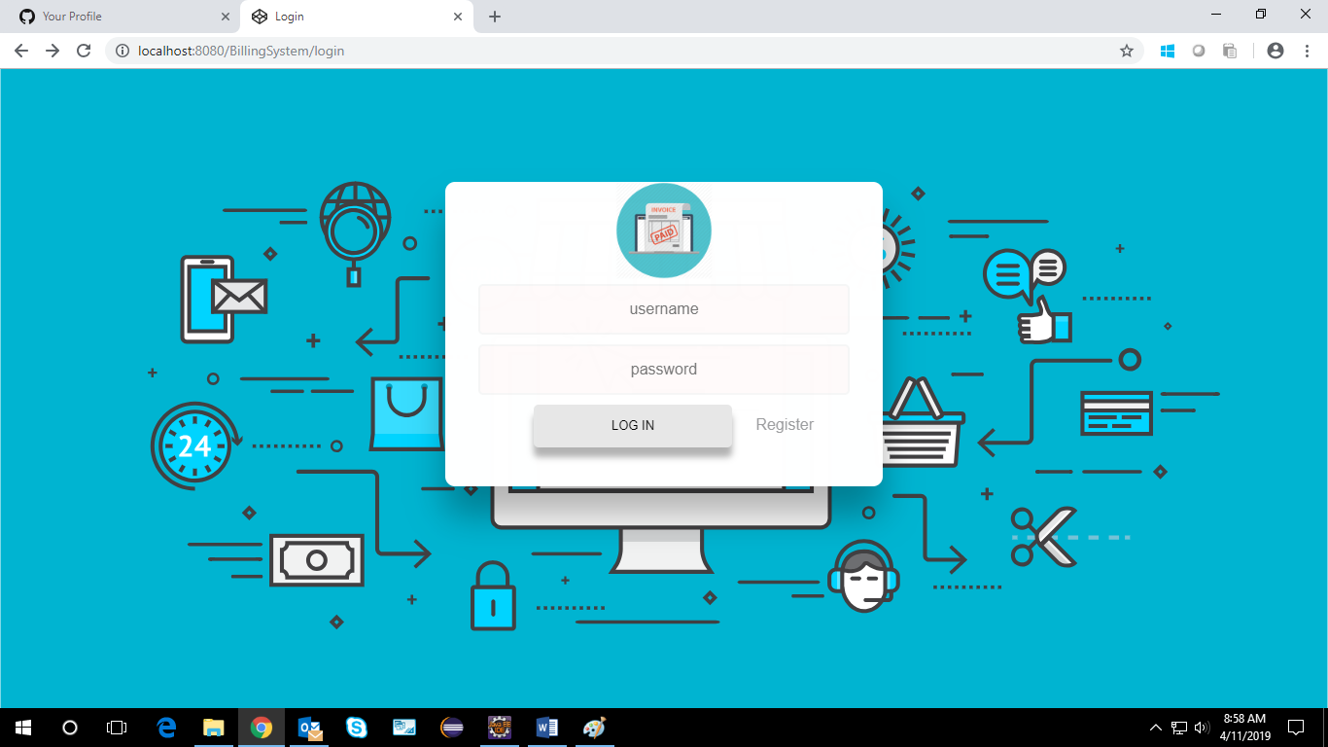

Here is a prototype on how the ‘User Registration’ page should look like.

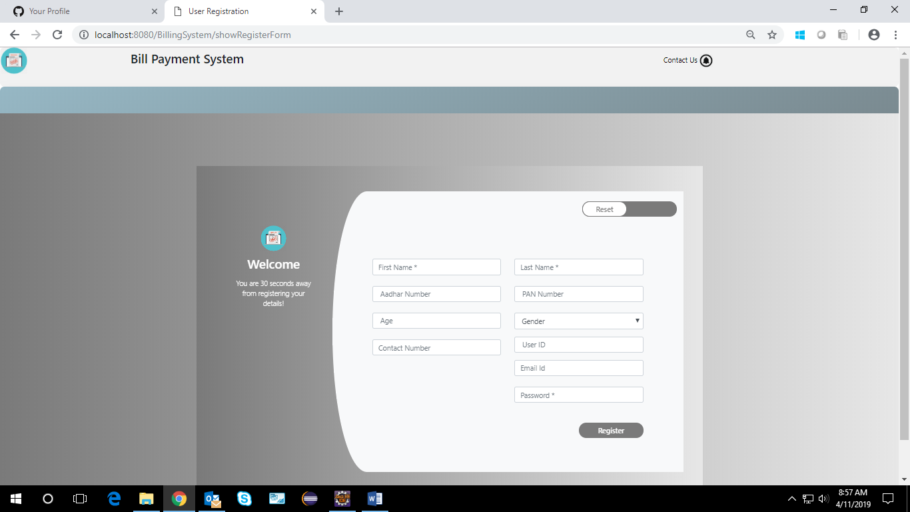

UI Field Validations
Please refer to the below requirements for field level validations:

- All fields are mandatory.
Password should have maximum 15 alphanumeric, space & can contain special characters (ex.!,@,#,%,*,& etc.)
- The Email ID format must be checked.
- Phone Number must be of 10 digits’ length.
- Age should be two digit numeric value.
- First Name, Last Name should contain only alphabets.
- Gender should be chosen from the dropdown options.
- PAN, Aadhar Number, UserId should be alphanumeric maximum.

Use case ‘User Credential Authentication’

Use case attributes
Use Case Description:

This use case deals with the authentication of the user credentials. The ‘user’ here shall be the operator of the system and will be keying in the user information into the system.

Scope:
- User credentials authentication
Actors:
User – the operator

Trigger:

Click ‘Login’ link, after keying in ‘Username’ & ‘Password’ field.

Pre-Condition:

User being able to access the login page

Post Condition:

User is in the Billing System Home Page.

Flow of Events:

User at homepage → Click ‘Pay Your Bills’ link → User at login page → Key in ‘Username’ & ‘Password’ field → User credentials are validated → Billing System Home page is displayed.

Primary Scenario:
A registered user – is able click ‘Login’ link, after keying in ‘Username’ & ‘Password’ field and get his credentials authenticated with the existing database entry.

Alternative Scenario:
A registered user – is able click ‘Login’ link, after keying in ‘Username’ & ‘Password’ field and unable to get his credentials authenticated. The user is presented with relevant error messages: Invalid username or password.

Business Rules
Business rules should be defined using the following attributes: -

- A registered user – is able click ‘Login’ link, after keying in ‘Username’’ & ‘Password’ field and get his credentials authenticated with the existing database entry.

UI Requirements
Here is a prototype on how the Billing System Login should look like.

Use case ‘Vendor Registration’

Use case attributes
Use Case Description:

This use case deals with the capture of vendor details. The ‘admin’ here shall be the operator of the system and will be keying in the vendor details.

Scope:

- Vendor Registration

Actors:

- Admin – the operator

Trigger:

Admin should get redirected to the ‘Vendor Registration’ page upon clicking on the ‘Vendor Registration’ link.

Pre-Condition:

Admin should be able to get redirected to the ‘Vendor Registration’ page upon clicking the ‘Vendor Registration’ link on the admin page.

Post Condition:

Admin is in the registration page & submit vendor details.

Flow of Events:

User at homepage → Click ‘Go As Admin’ link → User at loginpage → Click ‘Login’ button → Admin in the admin page → Click ‘Vendor Registration’ link → Vendor details are submitted and added onto the database

Primary Scenario:
Admin – is able to click ‘Vendor Registration’ link and able to provide vendor details and get vendor registered into the system.

Here is a prototype on how the vendor Registration should look like.

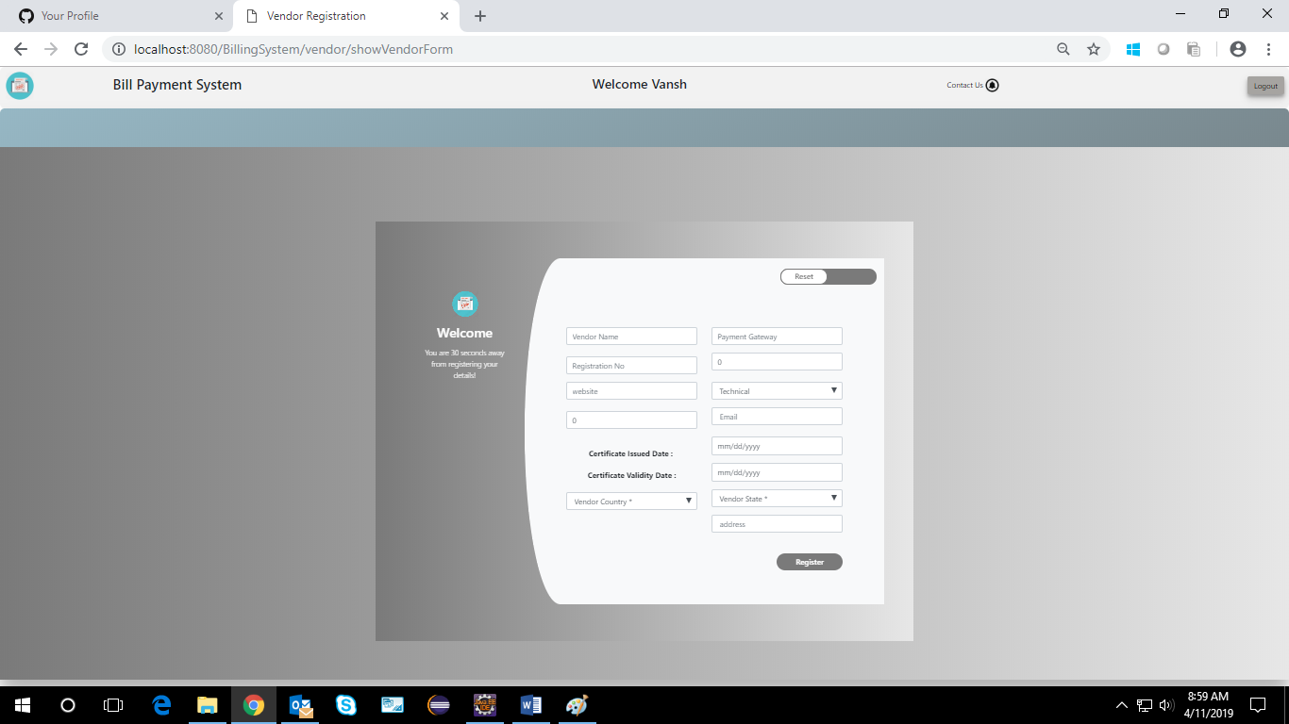

Business Rules

Business rules should be defined using the following attributes: -

- When the admin clicks on the vendor registration link, it should re-direct to vendor registration form.
    - User needs to fill some of the basic attributes/fields as mentioned below in requirement: Vendor name, Company Reg. No , Address, Country, State, E-Mail, Contact Number, Website, Certificate Issued date, Certificate Validity date, Year of, Establishment, Payment Gateway;
- Clicking ‘Register’ should validate the datatype constraints for each field
- Post-successful field level validation, save the information in the database
- Upon saving the information in the database, display the message ‘Your have successfully registered’.

UI Requirements
Here is a prototype on how the admin page should look like.

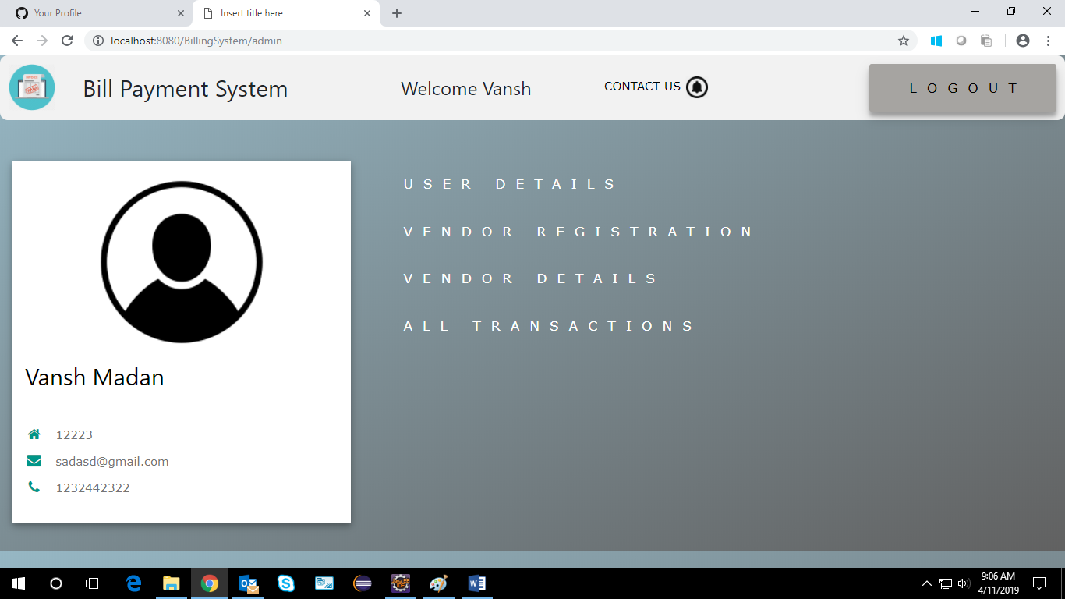

UI Field Validations
Please refer to the below requirements for field level validations:

- All fields are mandatory.
Vendor Name, Company Reg. No. should have maximum length of 50 input characters.
- The Email ID format must be checked.
- Website should be alphanumeric of 15 characters.
- Contact Number must be of 12 digits’ length.
- Payment gateway should be alphanumeric of 15 characters.
- First Name, Last Name should contain only alphabets.
- Vendor Type, Address, Country, State fields should be chosen from the dropdown options.
- Certificate Issued date, Certificate Validity date, Year of Establishment should be chosen from the dropdown date value.

Use case ‘Record Bill’

Use case attributes
Use Case Description:

This use case deals with the ability to record bill details pertaining to various categories. The ‘user’ here shall be the operator of the system and will be keying in the bill record(registration) details.

Scope:

- Record Bill

Actors:

- User – the operator

Trigger:

Click ‘Save and Exit’ button in the ‘Bill’ page

Pre-Condition:

User being able to access the ‘Record Your Bill’ page. User being able to reach ‘Record Your Bill’ page upon clicking any given bill type is redirected to the new bill addition link where user can register the details of the given bill type against the given fields like bill amount and payment options. Once the details have been successfully entered, user is given the option ‘Save and Exit’ to save the entered details in the database.

Post Condition:

User is displayed a popup displaying the message “Bill Form Saved Successfully” and is redirected to the initial ‘Record Your Bill’ page.

Flow of Events:

User at homepage → Click ‘Pay Your Bills’ link → User at login page → Click ‘Login’ button ->User at Record Your Bill page → Click the button corresponding to any given bill type → User is in the Bill Form page corresponding to the bill type , user selected in the previous step. →Bill Form details are submitted and added onto the database upon clicking the ‘Save and Exit’ -> User redirected to ’Record Your Bill’.

Primary Scenario:
A user – is able to select any given bill type and is able to add new bill details via a bill and post saving the form is redirected to ‘Record Your Bill’ Page ..

Business Rules

Business rules should be defined using the following attributes: -

- When the user clicks on any given Bill type say Electricity button, it is redirected to the ‘Pending Bills’ page where the user is provided an option to add new bill of previously selected type.
    - User needs to fill some of the basic attributes/fields as mentioned below in bill form requirement: Username, PAN card No., Amount to be paid, Card Holder Name, CVV Number, Credit Card Number;
- Clicking ‘Save and Exit’ should validate the datatype constraints for each field
- Post-successful field level validation, save the information in the database
- Upon saving the information in the database, display the message ‘Bill Form Data Saved Successfully’.

UI Requirements
Here is a prototype on how the ‘Bill Pay” page should look like.

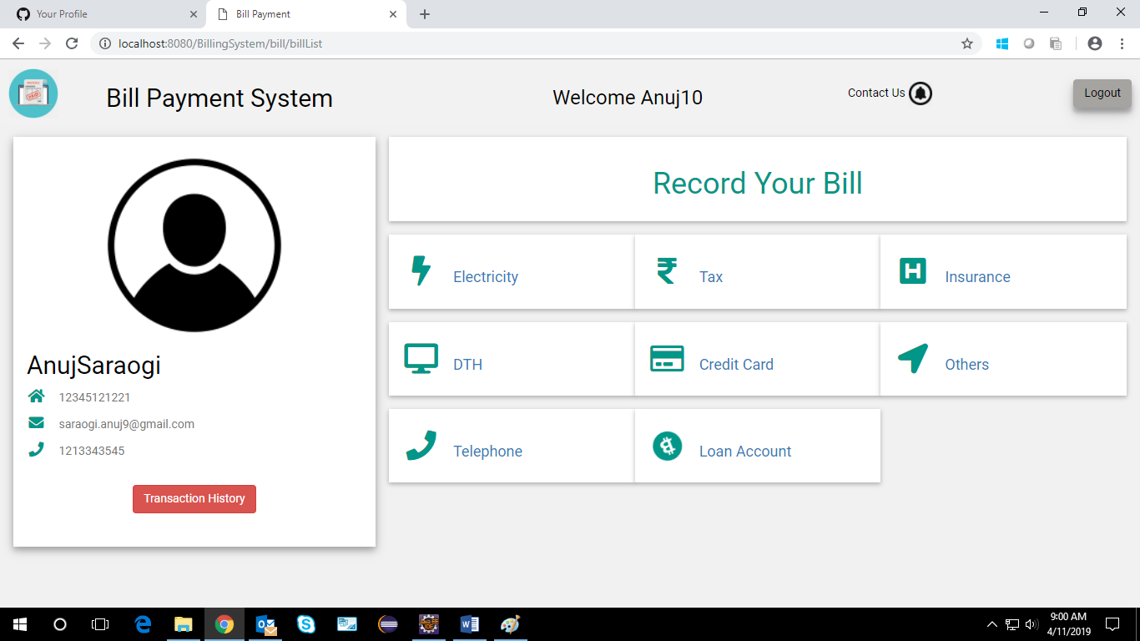

UI Field Validations
Please refer to the below requirements for field level validations:

- All fields are mandatory.
- PAN Number must be of 15 digits’ length
- Amount to be paid should contain only numeric digits.
- Credit Card Holder name should consist of alphabets only.
- Credit Card CVV field should contain only numerical digits of length 3.
- Credit card Number should be of exactly 12 digits.

Use case ‘Pending Bills’

Use case attributes
Use Case Description:

This use case deals with the ability of the system to provide information about pending bills for a given user of the given selected type by the user. The ‘user’ here shall be the operator of the system and will be keying in the pending bill details.

Scope: Pending Bills

Actors:

- User – the operator
Trigger:

Click any given bill type button in the ‘Record Your bill’ page.

Pre-Condition:

User being able to access the ‘Record Your Bill’. User being able to reach ‘Record Your Bill’ page upon clicking ‘bill type button like Electricity.

Post Condition:

User is in the ‘Pending Bills’ page where all the bills corresponding to the type selected by the user are listed.

Flow of Events:

User at homepage → Click ‘Pay Your Bills’ link → User at login page → Click ‘Login’ button ->User at Record your Bill→ Click Bill type button → User is in the Pending Bills page
Primary Scenario:
A user – is able to click any Bill type button and is able to see all the bills pending against him and the user is able to view or delete any of these pending bills he desires.

Business Rules
Business rules should be defined using the following attributes: -

- When the user clicks on the any given bill type button, it should re-direct to the pending Bill Form.
- User can view the details of any bill having pending status and is provided an option to modify or delete any of the pending bills listed against him.
- Clicking ‘delete’ should delete that particular bill from the pending list against the current user.
- Clicking ‘view’ against any pending bill should display the details of the corresponding pending bill against the user and should provide the user a link to go for Bill Payment.

UI Requirements
Here is a prototype on to reach Pending Bills by selecting bill type-as of now consider selecting electricity bill

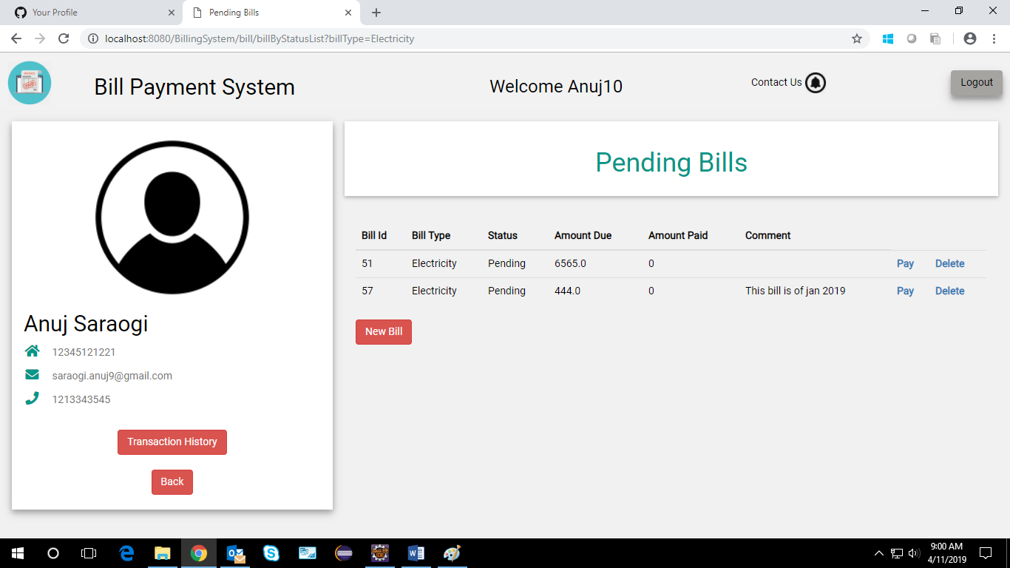

Use case ‘Bill Payment’

Use case attributes
Use Case Description:

This use case deals with the ability of the user to pay the pending bills listed against it.The ‘user’ here shall be the operator of the system and will be keying in the bill payment details.

Scope: Bill Payment

Actors:

- User – the operator

Trigger:

Click ‘Pay Bill’ button in the bill form page

Pre-Condition:

User being able to access the Record Bill Page & get redirected to the ‘Pending Bills’ page upon clicking against any bill type and on clicking against the view button corresponding to any of the bending bills listed ,user should be displayed the bill form and upon clicking the bill pay button , the status of transaction should be displayed and upon successful payment the corresponding pending entry from the database should be deleted and user should be redirected to the Record Bill Page.

Post Condition:

User is in the Bill form page & pays the bill by clicking on Pay bill Button.

Flow of Events:

User at homepage → Click ‘Pay Your Bills’ link → User at login page->
→ Click ‘Login’ button->User at Record your Bill→ Click Bill type button → User is in the Pending Bills Page->User clicks on view button->User clicks on Pay Bill button->User is redirected to Record your Bill page.

Primary Scenario:
A user – is able to click any Bill type button and is able to see all the bills pending against him and the user is able to view and pay any of the bills he desires by simply selecting the desired payment vendor and clicking on pay button.

Business Rules

Business rules should be defined using the following attributes: -

    - User needs to click on any of the bill types and should be able to see all the bills pending against him of the selected bill type.
- Upon clicking the view button, user should be redirected to bill form page where user can choose the payment vendor and select on pay bill button to pay the bill.
- Post-successful payment, the corresponding pending entry is deleted from the table.
- Thereafter we redirect User to ’Record Your Bill’ page.

UI Requirements
Here is a prototype of Bill Payment Page with Pay Bill button -

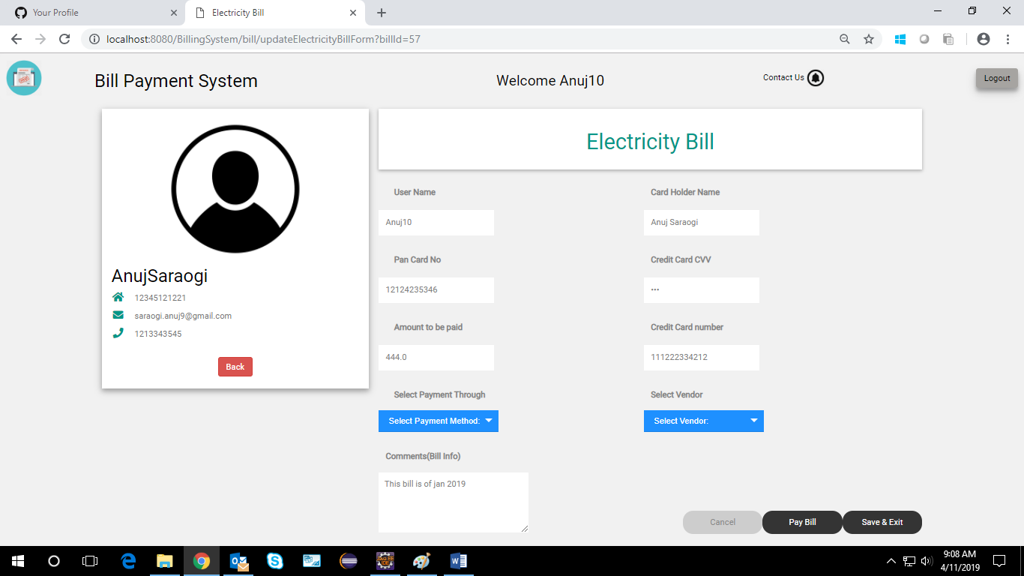

Here is a prototype of Bill Payment Page with Pay Bill button if a user select a new bill to be payed –

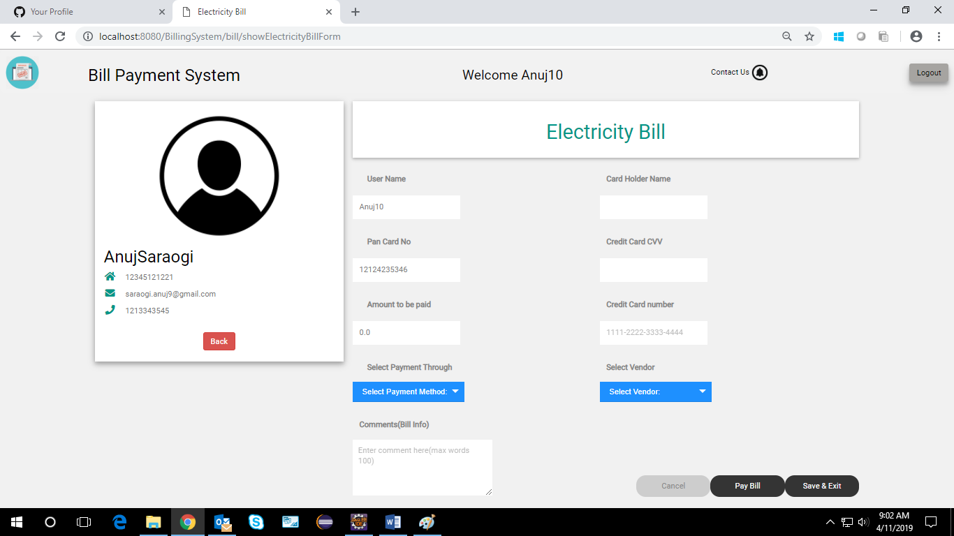

Database Design

Tables Structure
User Details:
Column Name | Data Type | Length | Nulls
firstName | varchar | 50 | N
lastName | varchar | 50 | N
username | varchar | 15 | N
age | int | 2 | N
gender | varchar | 6 | N
pan | varchar | 15 | N
contact_number | varchar | 10 | N
aadhar | varchar | 15 | N
emailId | varchar | 30 | N
password | varchar | 15 | N

Vendor Details:
Column Name | Data Type | Length | Nulls
vendorName | varchar | 50 | N
companyRegNo | varchar | 50 | N
vendorType | varchar | NA | N
address | varchar | NA | N
country | varchar | NA | N
state | varchar | NA | N
emailId | varchar | 30 | N
contactNo | long | 10 | N
website | varchar | NA | N
certificateIssueDate | Date | NA | N
certificateValidityDate | Date | NA | N
yearOfEstablishment | int | NA | N
paymentGateway | varchar | 15 | N

Bill Details:
Column Name | Data Type | Length | Nulls
billId | int | 50 | N
amount | float | 10 | N
cardNumber | varchar | 15 | N
billType | varchar | 50 | N
username | varchar | NA | N
pan | varchar | NA | N
vendorName | varchar | NA | N
billStatus | varchar | NA | N
paymentThrough | varchar | NA | N
cardCVV | varchar | NA | N
cardName | varchar | NA | N
cardExpiryDate | varchar | NA | N

Data Flow Diagram
